Title of the Event: AIML EXPO – 2025

Student Name: L.Ishitha
Roll No: 2420030041
Section: Sec-10

Organized by:
Department of Artificial Intelligence and Machine Learning, KLH University

Dates:
November 4th – 6th, 2025 | 10:00 AM – 4:00 PM

Event Summary:
The AIML Expo 2025 was an innovative platform organized by the Department of Artificial Intelligence and Machine Learning at KLH University to showcase student projects and research in emerging technologies. The event aimed to encourage creative problem-solving using AI and ML concepts. Participants presented projects addressing real-world challenges through software and hardware solutions. The expo featured interactive demonstrations, expert evaluations, and insightful discussions with faculty and industry professionals. It served as a great opportunity for students to exhibit their technical skills, innovation, and teamwork in developing AI-driven solutions for societal well-being.

Key Highlights:
The event featured over 50 student projects, covering areas like Machine Learning, Data Science, Computer Vision, and NLP-based applications. Interactive sessions and project demos allowed participants to exchange ideas and receive constructive feedback from judges. My project, “Mental Health Chat Analyzer,” gained appreciation for addressing emotional well-being using AI. The judges commended its social relevance, technical execution, and user-friendly design. The Expo successfully fostered innovation, teamwork, and AI-driven thinking among students.

My Participation:
I actively participated by presenting my project titled “Mental Health Chat Analyzer (Software-Based Approach),” which uses Natural Language Processing (NLP) to analyze chat conversations and detect emotional states such as stress, anxiety, or depression. I explained the working model, objectives, and societal impact of the system to the judges and visitors. Through this event, I enhanced my presentation skills, teamwork, and confidence in explaining technical concepts. It was a valuable learning experience that motivated me to further explore AI in the field of mental health and emotional well-being.

Event Photographs:
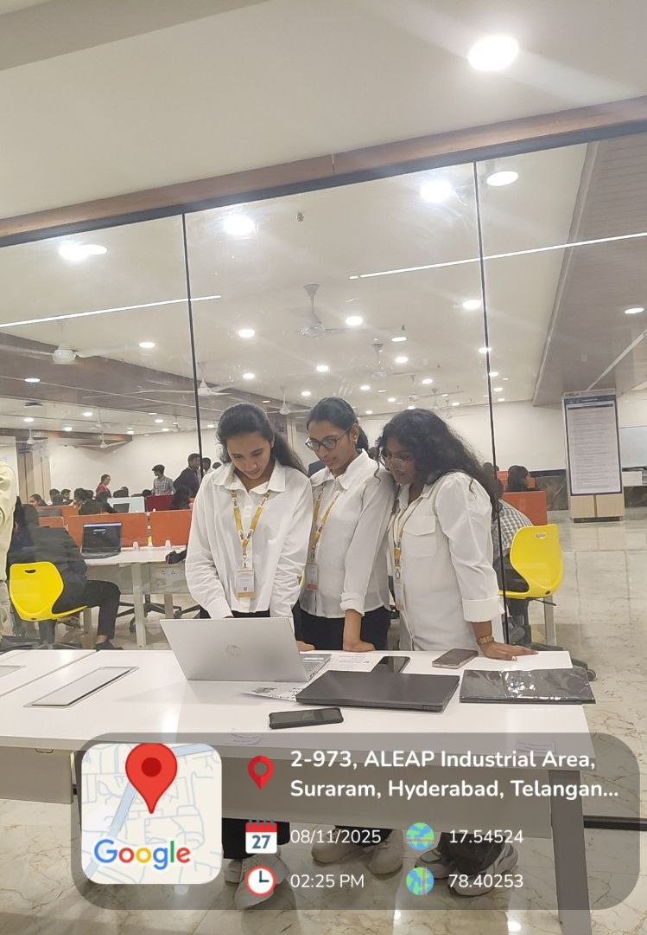

Conclusion:
The AIML Expo 2025 was an enriching experience that enhanced my technical and communication skills. It provided an excellent platform to connect with peers and experts, gain constructive feedback, and learn about the innovative applications of AI and ML in real-world problems. Participating in the expo boosted my confidence and inspired me to continue exploring AI for social good.

Acknowledgment:
Special thanks to Prof. Venkateswara Rao Pulipati, Department of AIML, and KLH University for organizing this inspiring event and recognizing my project on Mental Health Well-Being. Their guidance and encouragement played a vital role in the success of my participation.

